**SALES REPORT PROJECT USING POWER BI**

**STEP1 - REQUIREMENTS GATHERING AND LOADING DATA IN POWER BI**

Assemble a sales reports with different visuals to best show the Sales Insights in one page Dashboard. Feel free to use your imagination to best represent the data you have available.

1. Sales (folder by year)(2014 to 2017)
2. Categories (Excel)
3. Geography (Excel)
4. Product (CSV / Database)
5. SalesRep (Excel)
6. SubCategories (Excel)

* **Sales tables** are **Fact tables**.
* All other tables are **Dimension tables**.
* While loading sales tables we will loaded them as a folder and combined all the tables in it so that any new table added in the folder will be added to report automatically after a refresh and the reports will be updated.

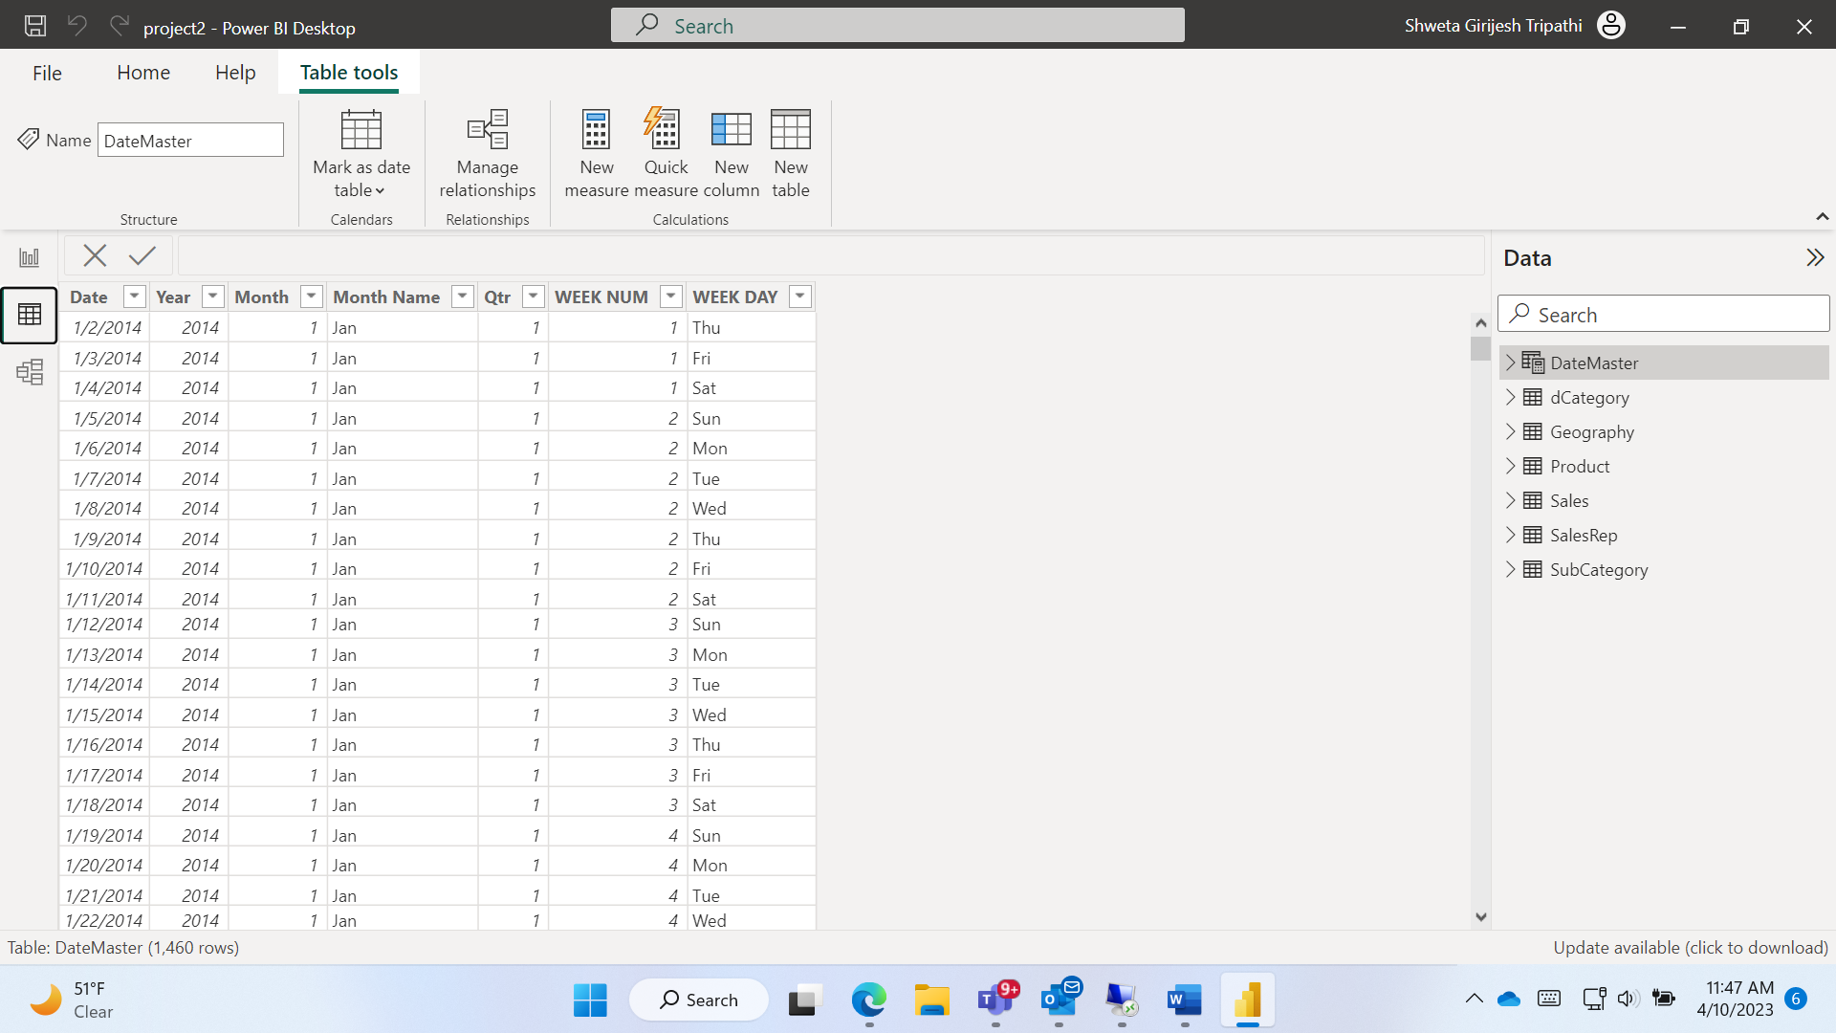

**STEP 2 - TRANSFORM/CLEAN DATA**

**ISSUES AND FIXES**

* Sales Rep ID column in sales and Sales Rep is in different formats so bringing it to a common format.
* Its better to join Sales and Sales Rep tables
* Category key in SubCategory and dCategory tables are in different formats
* Problem with originial Sales tables date columns it was fixed in excel source file using following steps
  + Text to column -> seperator(comma) -> Date(DMY)->finish
* Dimension tables cannot have duplicates in dimension tables so we removed all the duplicates
* Changed headers of Geography and Sales Rep table
* In SubCategory table “ID - 1” replaced with “1”.
* In sales table remove Source name column as it is unnecessary
* Split country and city using separate by delimiter option and rename columns as “country” and “Town”.
* Remove duplicates in Product table
* Create a “Geokey” column as index in Sales and Geography tables and **merge** it with sales and remove unnecessary columns from Sales table (using outer join with fuzzy matching).

**STEP 3 - MODELLING**

* Using manage relationship join all the table to fact table
* Create a **DateMaster table** as it is very useful for time related analysis in report using **DAX**
  + DateMaster = CALENDAR(FIRSTDATE(Sales[Date]),LASTDATE(Sales[Date]))
* Add different columns in DateMaster using DAX
  + Year = YEAR(DateMaster[Date])
  + Month = MONTH(DateMaster[Date])
  + Month Name = FORMAT(DateMaster[Date],"MMM")
  + Qtr = QUARTER(DateMaster[Date])
  + WEEK NUM = WEEKNUM(DateMaster[Date])
  + WEEK DAY = FORMAT(WEEKDAY(DateMaster[Date]),"DDD")

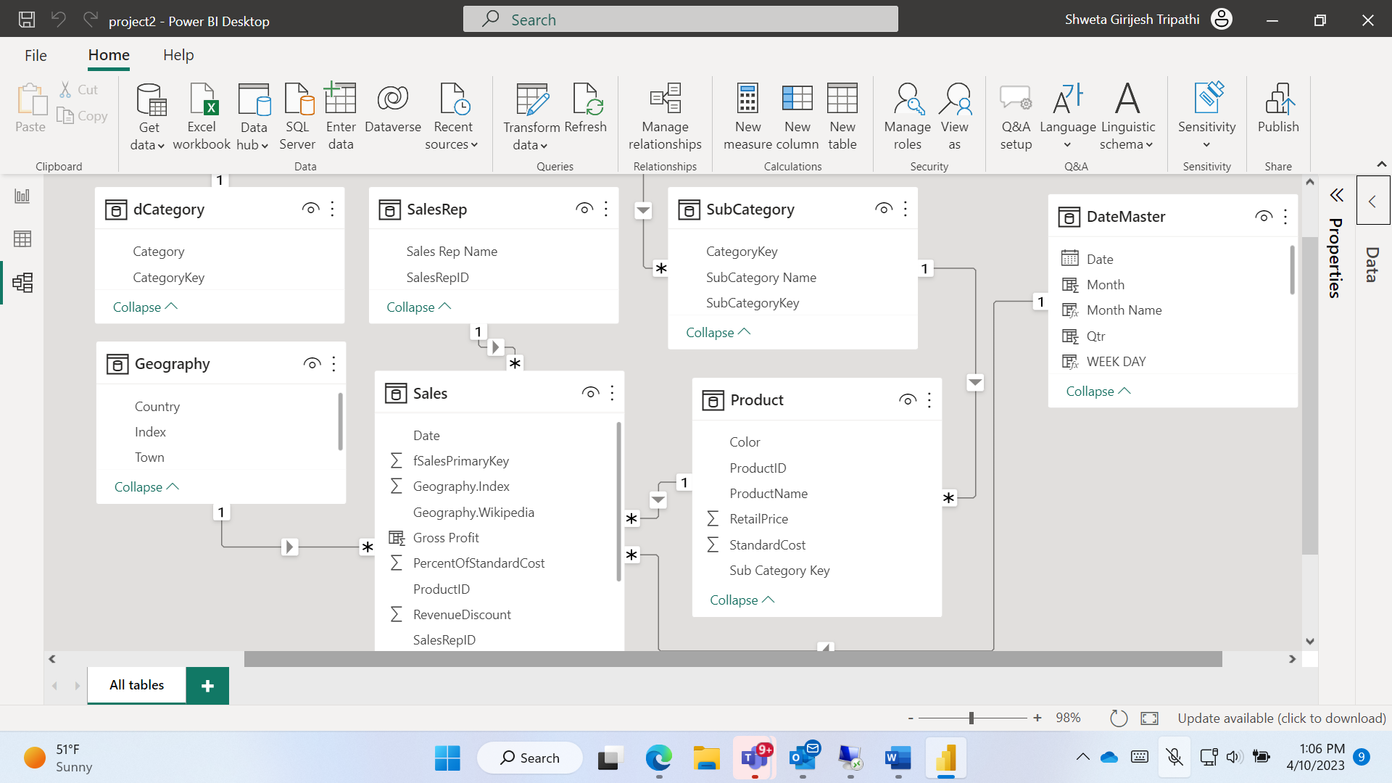

**STEP 4 - USING DAX TO PERFOM CALCULATIONS**

* Calculate **Total Revenue** in Sales table, using the Product’s Retail Price, and multiplying it by the Units
  + Total Revenue = Sales[Units]*RELATED('Product'[RetailPrice] )
* Calculate **Total Cost** in Sales table, using the Product’s Standard Cost, and multiplying it by the Units.
  + Total Cost = Sales[Units]*RELATED('Product'[StandardCost] )
* Calculate **Gross Profit** in Sales: Total Revenue – Total Cost
  + Gross Profit = Sales[Total Revenue]-Sales[Total Cost]
* Calculate a **Gross profit MoM growth Change%** measure that could benefit us in decision making
  + Tot Profit = sum(Sales[Gross Profit])
  + Prev Month Profit = CALCULATE([Tot Profit],PREVIOUSMONTH(DateMaster[Date]))
  + MOM Profit = ([Tot Profit]-[Prev Month Profit])/[Prev Month Profit]
* Calculate the following time measures for QoQ Growth is required
  + Tot rev = SUM(Sales[Total Revenue])
  + Prev Qtr = CALCULATE([Tot rev],PREVIOUSQUARTER(DateMaster[Date]) )
  + QoQ growth = ([Tot rev]-[Prev Qtr])/[Prev Qtr]

**STEP 5 - CREATION OF REPORT**

* Add title - Sales Report
* Add slicer
  + Country
  + Year
  + Month name
* Create cards
  + Total revenue
  + Gross profit
  + Units
* Pie chart
  + Total revenue by subcateory
* Donut Chart
  + Total revenue by category
* Multi card
  + Top 5 sales rep
* Scroller
  + Product name v/s Total revenue
* Waterfall chart
  + Category-Year
  + Breakdown-product
  + Value-Total revenue
* Stacked chart
  + Total revenue by product name and subcategory
* Line graph
  + QoQ report
  + MoM report
* Edit interactions for waterfall chart

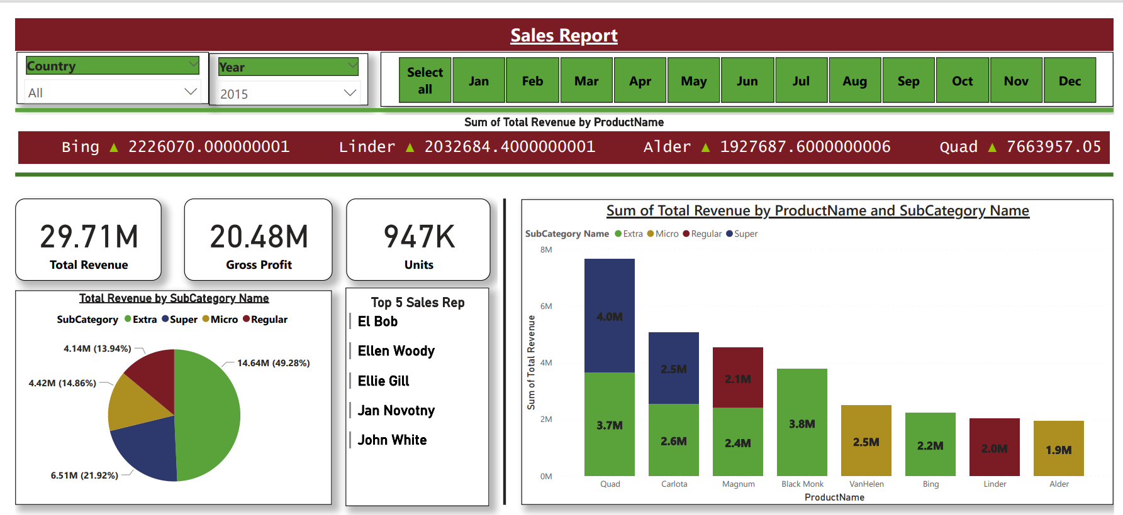

**STEP 6 – PROVIDE ROW LEVEL SECURITY**

**STEP 7 – CREATE WORKSPACE AND PUBLISH REPORT**

**STEP 8 – CREATE GATEWAY AND CONFIGURE REFRESH SCHEDULE**

**STEP 9 – CONFIGURE SUBSCRIPTIONS AND ALERT**

**STEP 10 – CREATE APP AND SHARE LINK**